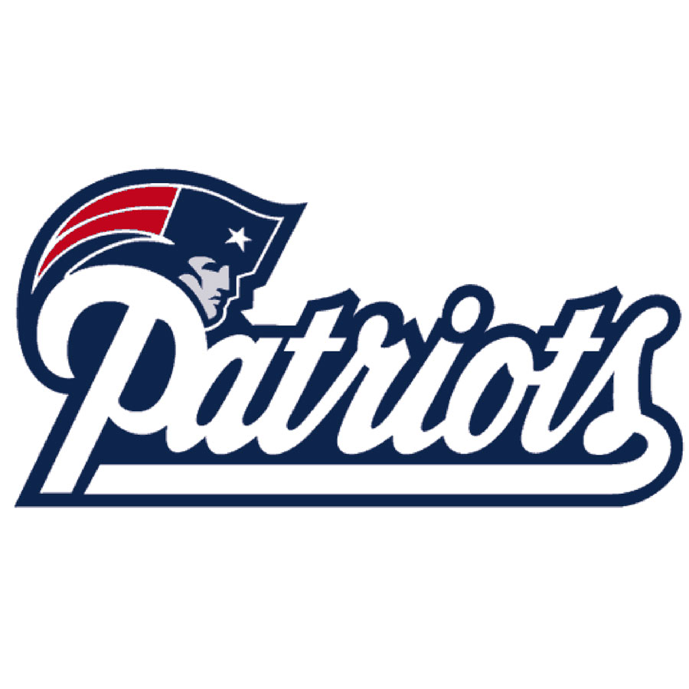

Farmville Middle School

October 16, 2024

Dear Parent/Guardian:

I am writingthis letter to notify you that Farmville Middle Schoolhas been dually designated as both a North Carolina Low-Performing school and a federally identified Targeted Support & Improvement Additional Targeted Support (TSI-AT) school by the North Carolina State Board of Education.

As defined in G.S. 115C-105.37: “The State Board of Education shall identify low-performing schools on an annual basis. Low-performing schools are those that earn an overall school performance grade of D or F and a school growth score of "met expected growth" or "not met expected growth" as defined by G.S. 115C-83.15.” Legislation (G.S. §115C-83.15) passed during the 2013 long North Carolina General Assembly session provides parents with an additional measure of school performance in the form of School Performance Grades. Beginning with the 2013–14 school year, the annual North Carolina School Report Cards display a letter grade of A, B, C, D, or F for each school in the state.

School Performance Grades are based 80 percent on our school’s achievement score (student proficiency) and 20 percent on students’ academic growth. At FMS, our achievement score for the 2023-2024 school year is based on how well our students performed on Grades 6–8 Mathematics, Grades 6–8 English Language Arts/Reading, Grade 8 Science, and NC Math 1.  FMS received a School Performance Grade of D and a growth designation of Met for the 2023–2024 school year.

In addition, per the Every Student Succeeds Act (ESSA) Section 1111(d)(2), schools receive the federal identification of TSI-AT in North Carolina by having one or more of the following subgroups receive a subgroup performance grade score at or below the lowest 5% of schools across the state during the 2022-2023 academic year; and being identified as a consistently underperforming subgroup for the previous year. Subgroup performance scores are provided for the following subgroups of students: (1) Students with Disabilities, (2) Economically Disadvantaged, (3) Black, (4) White, (5) Hispanic, (6) Asian-Pacific Islander, (7) Multi-racial, and (8) English Learners.

As a dually designated TSI-AT and NC low-performing school, FMS is required to develop a comprehensive improvement plan that specifically addresses how the school will improve student achievement. The plan will also include strategies that our district or charter will employ to support Farmville Middle’s improvement efforts.  The comprehensive improvement plan will address the following areas:

* Standards-aligned Instruction
* Professional Learning Communities (PLCs)
* Instructional Leadership
* Implementation of a Tiered Instructional System
* Data-Driven Decision Making
* Family and Community Engagement

We have set the following goals for FMSthis year:

* Implement the PLT process with fidelity to move from pre-initiating to sustaining on the implementation continuum.
* Increase school proficiency by 4 to 7 percentage points.
* Reduce suspensions and student time out of class by 20% with the implementation of the Capturing Kids’ Hearts program.
* Will attain i-Ready stretch growth in Reading and Math by the end of the year.

Here are some strategies that FMS will be implementing to improve student outcomes:

* All teachers will employ effective classroom management and reinforce classroom rules and procedures by positively teaching them.
* Instructional Team will develop standards-aligned units of instruction for each subject and grade level.
* The school will implement a tiered instructional system that allows teachers to deliver evidence­ based instruction for each aligned with the individual needs of students across tiers.
* All teachers will be attentive to students' emotional states, guide students in managing their emotions, and arrange for supports and interventions when necessary.
* The school will develop and implement consistent, intentional, and on-going plans to support student transitions for grade-to-grade and level-to-level.
* The LEA will have an LEA Support and Improvement Team.
* A Leadership Team will consist of the principal, teachers who lead the Instructional Teams, and other professional staff meets regularly (at least twice a month) to review implementation of effective practices.
* The school will establish a team structure among teachers with specific duties and time for instructional planning.
* The principal will monitor curriculum and classroom instruction regularly and provides timely, clear, constructive feedback to teachers.
* The LEA/School will regularly look at school performance data and aggregated classroom observation data and uses that data to make decisions about school improvement and professional development needs.
* The LEA/School will establish a system of procedures and protocols for recruiting, evaluating, rewarding, and replacing staff.
* The school will regularly communicate with parents/guardians about its expectations of them and the importance of the curriculum of the home (what parents can do to support).

Parent engagement is at the heart of our school improvement efforts. Here are some ways you can help:

* Ensure you and your child know the academic expectations for your child this school year.  A list of learning objectives in student-friendly language is available from your child’s teacher(s).
* CallFMS Student Services at 252-753-2116 if you have questions or concerns about your child or to set up an appointment to meet with a school staff member who will be working with your child.
* Make sure that your child is prepared and attends school each day.
* Monitor your child’s homework.
* Monitor the progress your child is making and attend meetings with your child’s teacher(s).
* Keep track of our website and social media sites .
* <https://www.pitt.k12.nc.us/fms#calendar22645/20241016/month>
* <https://www.facebook.com/profile.php?id=100063773821255>
* ClassDojo
* Volunteer.
* Join the FMS Academic Boosters.

Additionally, listed below are a few resources available to help:

* Graduation requirements: [www.ncpublicschools.org/gradrequirements/](http://www.ncpublicschools.org/gradrequirements/)
* K-12 standards in academic subjects: [www.ncpublicschools.org/curriculum/](http://www.ncpublicschools.org/curriculum/)
* State student achievement test results: [www.ncpublicschools.org/accountability/](http://www.ncpublicschools.org/accountability/)
* N.C.School Report Cards: <https://www.dpi.nc.gov/data-reports/school-report-cards>

We are committed to improving student performance. It is important to remember that just as no one single score or grade tells the whole story of a student, neither does it tell you everything about the performance of a school or the opportunities that our school provides. The intent of receiving these designations is to improve educational outcomes for all students, close achievement gaps, increase equity, and improve the quality of instruction. We’re excited about this school year and are working to make it a success for your child. Already, we have:

* Strong beginning to Capturing Kids’ Hearts
* Parent ClassDojo membership is high
* Student Athletes are doing well with their academics and athletics
* Started the first Strength and Conditioning Middle School Encore Class in PCS.
* Community sponsors have purchased various equipment and resources for FMS.

If you have questions about the content of this letter, please contact Principal Miller at millerj1@pitt.k12.nc.us or 252-753-2116.

Sincerely,

Jeremiah Miller, Ed.S

Principal of Farmville Middle School